Consuming JaxWS Web Service Using Spring boot application

1. Create new Spring Boot project: “boot-jaxws-client”

DO NOT CHOOSE ANY STARTER

Project (Packaging) Type: JAR

2. Right click on “boot-jaxws-client” project > New > Other > Web Service Client

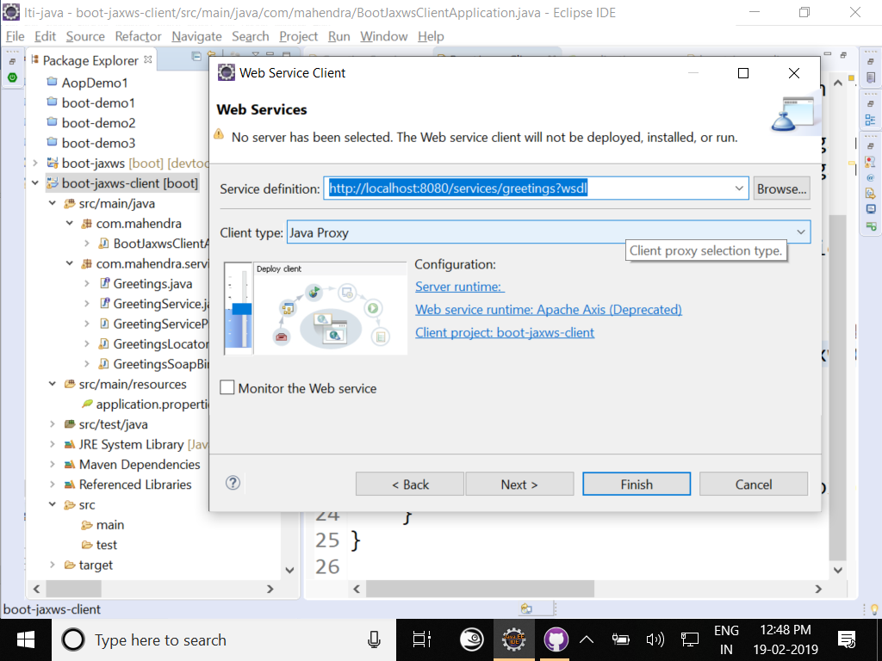

Click on Next

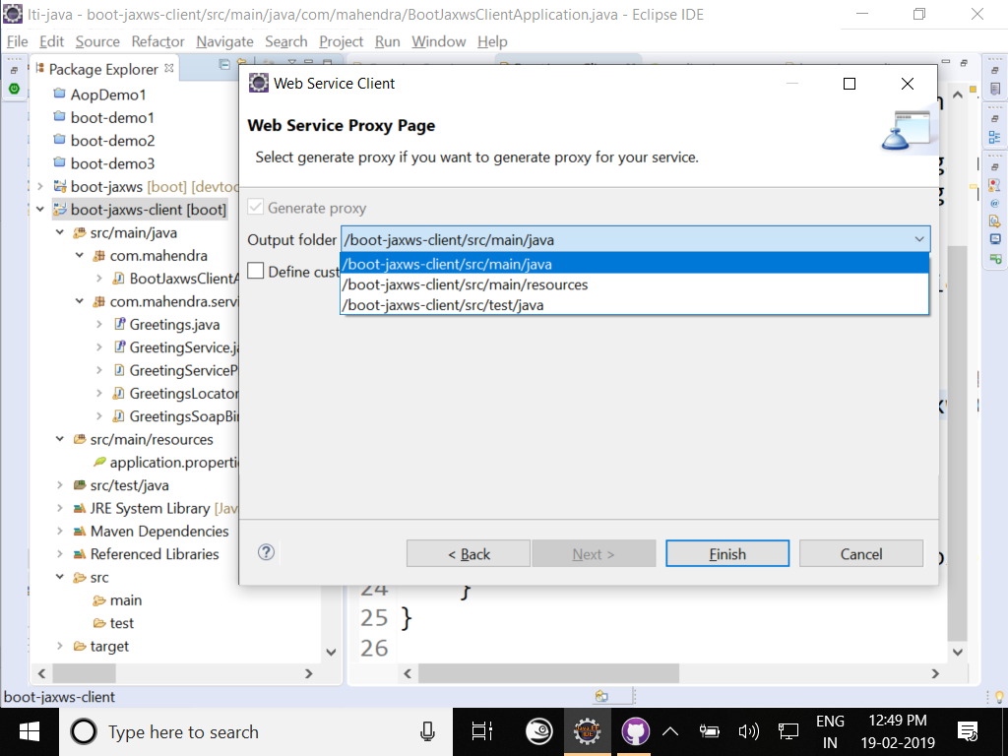

Choose correct directory (src/main/java) as a destination

Click “Finish”

3. Open “Application” class and define a new bean

@Bean

**public** GreetingService service() {

**return** **new** GreetingServiceProxy();

}

@Autowired GreetingService service;

4. Modify application class to implements interface “CommandLineRunner”

Write following method:

@Override

**public** **void** run(String... args) **throws** Exception {

System.***out***.println("Invoking service...");

String message = service.greet();

System.***out***.println("Message from service: "+message);

}